## Modify the mock user file

C:\Users\gmacdona\repos\Portal\src\Portal\src\Portal.Mock\ReferenceMockData

Right click at solution level

Select Set Start up project

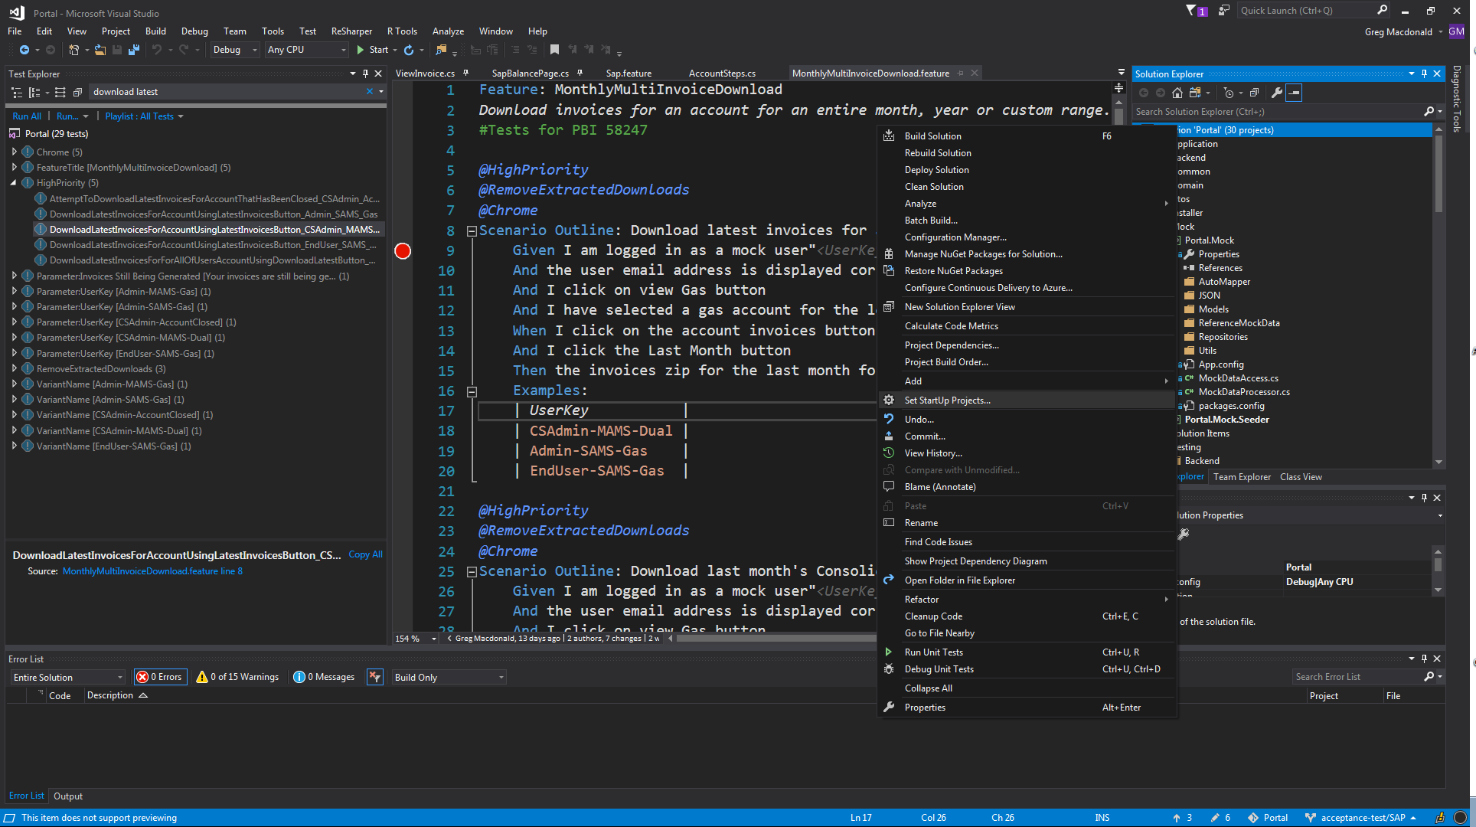

Set Single startup project to Portal.Mock.Seeder

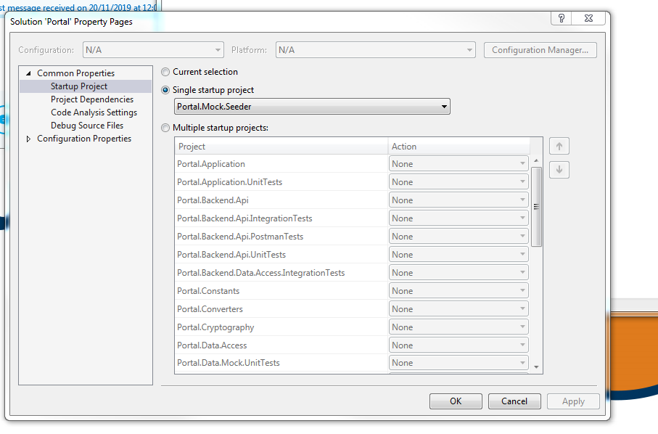

This should only need to be done once.

Use Task Manager to make sure there are no ChromeDrivers running

Select Build ->Rebuild Solution

Once this is complete, click on Start (green arrow)

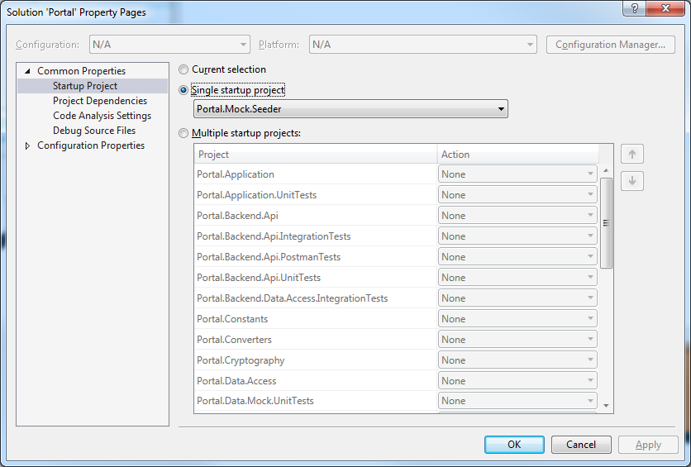

Once ‘Database successfully updated with mock data’ displayed, select this window and press space to make it disappear.

